End-to-End Open Air Interface

Round-Test Trip

Victor Hugo Goldwin  
*Department of Electrical Engineering,*  
*School of Electrical Engineering and Informatics, Bandung Institute of Technology*Bandung, Indonesia  
13222085@std.stei.itb.ac.id

*Abstract*— The rapid evolution of 5G technology has driven extensive research and development in software-defined radio (SDR) and open-source implementations. OpenAirInterface (OAI) provides an open-source platform for testing and validating 5G networks. This study evaluates the end-to-end performance of OAI by deploying and testing a 5G Standalone (SA) setup, focusing on connectivity between the Core Network (CN5G), gNodeB (gNB), and User Equipment (nrUE). The methodology includes setting up hardware and software components, performing connectivity tests, and analyzing system logs. The results highlight key performance metrics such as Reference Signal Received Power (RSRP), Signal-to-Noise Ratio (SNR), and Round-Trip Time (RTT) with the results having near ideal values because it is done as a simulation test. Challenges encountered include dependency management and outdated software features, requiring manual workarounds. The findings provide valuable insights into OAI’s performance in a simulated environment and its feasibility for further research and real-world deployment.

Keywords—Open Air Interface (OAI) 5G, gNodeB (gNB), User Equipment (UE), Round-Trip Time (RTT)

# Introduction

The rapid evolution of 5G technology has led to increased research and development in software-defined radio (SDR) and open-source implementations of 5G networks. OpenAirInterface (OAI) is an open-source platform for 5G research, enabling academic institutions, industry professionals, and network operators to test, develop, and validate their 5G implementations. OAI provides a fully integrated software stack for the User Equipment (UE), the gNodeB (gNB), and the Core Network (5GC), making it viable for end-to-end testing of 5G networks.

This study aims to evaluate the end-to-end performance of the OAI framework by deploying and testing a 5G Standalone (SA) setup. The focus is on connecting CN5G, gNB, and nrUE, followed up with a ping test to see the end-to-end performance. While doing this study, challenges encounterd mostly on software installation and preparation where some of the features are deprecated and need to do a workaround.

The methodology involves configuring the necessary software and hardware components, running performance tests, analyzing logs, and troubleshooting errors. The results of this study provide valuable insights into the limitations and advantages of OAI for 5G development.

The composition of the paper as follows: Methods and preparations are discussed in Section 2, Results and Analysis are presented in Section 3. Finally, section 4 concludes the paper.

# Metholodgy

This section discusses in detail the methodology employed in this test. The employed methodology consists of five steps and futher discussed in subsequent sections.

## Device Requirements

Device specification to set up the test is a laptop or PC with terminal in Linux OS. For this test, it was achieved by using Oracle VirtualBox to generate a Virtual Machine with Ubuntu to implement Linux OS. Recommended Ubuntu version to use is 24.04 LTS or above. This set up requires partition of the host’s device resources, such as cores, RAM, and storage spaces.

## Software Installation

The round-test trip done in this paper consists of three OAI components such as CN5G (Core Network), gNB (gNodeB), and nrUE (New Radio User Equipment). Each of this component needs to be set up properly to work as intended, especially the dependencies installation. The whole process of installation can be followed as instructed on OAI gitlab website [2].

## Running the Connectivity Test

After installing the dependencies, the last step would be to build and run each component as the round-trip test. The whole building and running process of CN5G, gNB, and nrUE is also instructed on the OAI gitlab website [3]. The round-trip test itself is done by doing a ping test to see the connectivity and response time of the connection between CN5G, gNB, and nrUE. If the ping test gave back a result, it’s implied that the connection is successful.

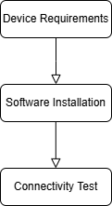

1. Flowchart Process of Methodology

# Results and Analysis

After finished doing the tests, the problem that got encountered on the process are mostly libraries that can’t be installed or not installed from the previou step so need some workaround such as downloading the library manually.

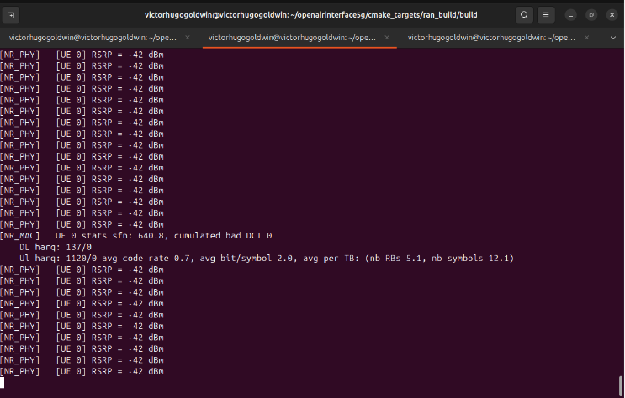

1. Terminal Logs After nrUE Runned

Figure 2 shows the terminal after the nrUE runned showing it successfully connected with gNB with some parameters that can be extracted such as avg code rate 0.7, which usually imply the UL Code Rate and RSRP with the value -42dBm.

UL (Uplink) shows the efficiency performance of uplink data transmission. UL, with the value of 0.7, means the transmission efficiency on the uplink is 70% and most of the data are transmitted.

RSRP (Reference Signal Received Power) represents the average power of reference signal received by UE from gNB. With it being measured in dBm, the more negative the number, the smaller the power received by UE and *vice versa*. The value -42dBm indicates the signal is received quite well without too much power loss, which could happen because of reasons, such as high transmitted power from gNB and good simulation environment [4]. The test itself is done in a simulated environment, hence the near ideal results.

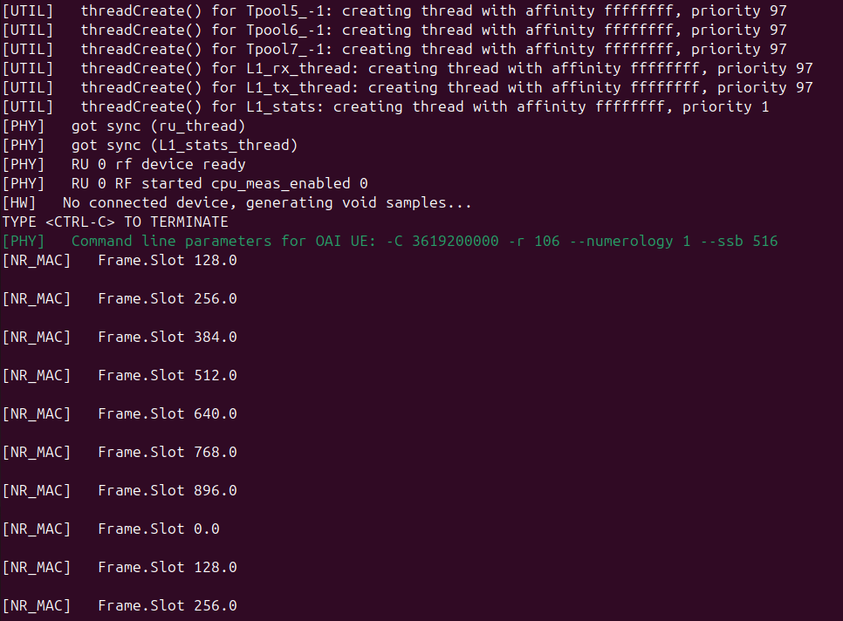

(a)

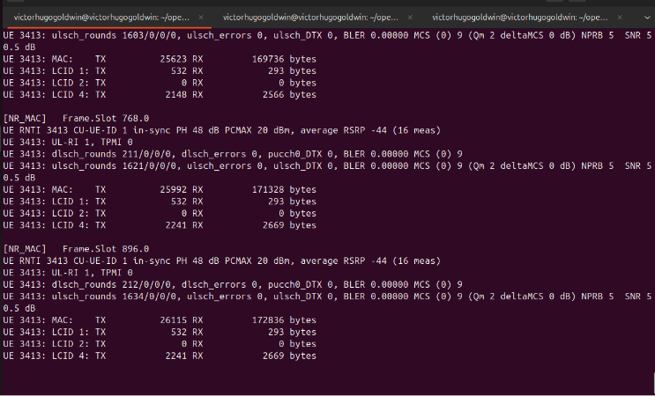

(b)

1. Terminal Logs of gNB (a) Before and (b) After nrUE Runned

Figure 3 shows the difference between before and after the nrUE runned on the gNB. The difference in display shows that the nrUE successfully connected and start the transmission and receive between the two.

Figure 3a shows the gNB being runned before nrUE connected to it. It shows that no physical device connected to it and preparing void samples for the simulations. The frame.slot represents the number of frame and slot index in the 5G NR time domain with the number of slots per subframe varies with the numerology and usually its divideable by 2.

Figure 3b shows the gNB after nrUE connected to it. From the picture, it shows how much data is being transmitted and received in bytes. MAC (Medium Access Control) is a sublayer of layer 2 in the 5G NR with LCID (Logical Channel ID) identifies different types of logical channel in the MAC [5]. Another thing that it gave is SNR (Signal-to-Noise Ratio) of the signal to be 50.5 dB meaning the signal is much more dominant than the noise. This could be caused by the environment created in the simulation, where in real life, the SNR number is usually much lower than that [4].

1. Terminal Logs After Ping Test

Figure 4 shows the result of the connectivity or ping test with 5 packets sample. As the result shows, none of the packets transmitted is lost (0% packet loss) with the RTT values given at the end of the line. The process itself is quite stable, around 15.4 ms on average for a packet to be transmitted and received back, with some occurrence of inconsistency, but the low and high RTT times still averages around 15 ms. This is in the range of the ideal RTT values as stated in one of the references [6].

1. Data Summary

| Parameter | Observed Value |
| --- | --- |
| RSRP | -42dBm |
| SNR | 50.5dB |
| UL Code Rate | 0.7 |
| RTT (min/avg/max/mdev) | 6.892/15.445/24.579/5.914 ms |
| Packet Loss | 0% |

# Conclusion

This study successfully deployed an OAI-based 5G SA network and evaluated its end-to-end performance. The connectivity test showed a stable RTT of 15.4 ms with 0% packet loss, indicating a well-functioning network in a simulated environment. The RSRP of -42 dBm and SNR of 50.5 dB suggest that the simulated network operates under near-ideal conditions.

Challenges encountered included dependency issues and outdated software, requiring manual installations. Despite these hurdles, the study confirms that OAI is a viable platform for 5G research and testing, with the potential for further refinement to improve real-world applicability.

Future work should involve testing in non-ideal conditions, including real-world deployments with environmental interferences, to validate the feasibility of OAI for industry applications.

##### References

1. OpenAirInterface 5G, "OAI 5G NR Documentation," [Online]. Available: <https://openairinterface.org/>.
2. Schmidt, Robert, “OAI Documentation Overview,” [Online]. Available: <https://gitlab.eurecom.fr/oai/openairinterface5g/-/blob/develop/doc/README.md>.
3. Schmidt, Robert, “OAI 5G NR SA Tutorial with OAI nrUE,” [Online]. Available: <https://gitlab.eurecom.fr/oai/openairinterface5g/-/blob/develop/doc/NR_SA_Tutorial_OAI_nrUE.mdK>.
4. 3GPP, "Study on scenarios and requirements for next generation access technologies," 3rd Generation Partnership Project (3GPP), TR 38.913, Jun. 2020. [Online]. Available: <https://www.3gpp.org/ftp/Specs/archive/38_series/38.913/38913-f60.zip>.
5. 3GPP, "NR; Medium Access Control (MAC) protocol specification," 3rd Generation Partnership Project (3GPP), TS 38.321, Dec. 2020. [Online]. Available: <https://www.3gpp.org/ftp/Specs/archive/38_series/38.321/38321-g60.zip>.
6. M. Shafi, A. F. Molisch, P. J. Smith, T. Haustein, P. Zhu, P. D. Silva, F. Tufvesson, A. Benjebbour, and G. Wunder, "5G: A tutorial overview of standards, trials, challenges, deployment, and practice," *IEEE Journal on Selected Areas in Communications*, vol. 35, no. 6, pp. 1201–1221, Jun. 2017. [Online]. Available: <https://ieeexplore.ieee.org/document/7894280>.